1702CS751 |  | CLOUD COMPUTING LAB | L | T | P | C
 |  | LIST OF EXERCISES | 0 | 0 | 2 | 1
List of Experiments:
- Find procedure to install and configure VMware Workstation
- Find procedure to create and run the virtual machine of different configurations. Check how many virtual machines can be utilized at particular time
- Find procedure to create virtual machines of different configuration and install desired operating system.
- Install a C compiler in the virtual machine and execute a sample program.
- Find procedure to attach virtual block to the virtual machine and check whether it holds the data even after the release of the virtual machine.
- Find procedure to install storage controller and interact with it.
- Find procedure to recover a virtual machine from snapshot
- Find procedure to convert a virtual machine into template
- Find procedure to create virtual machine from templates
- Find procedure to perform networking between virtual machines

Course Coordinator
J. NOORUL AMEEN
AP/CSE
EGSPEC

- Find procedure to install and configure VMware Workstation
Aim:
To find a procedure to install and configure VMware Workstation
Procedure:
- Launch the VMware workstation installer
- Accept the license agreement and click next

- Follow the installation wizard by clicking next button and click install button
- Enter the license key and click finish

- After installation launch VMware workstation
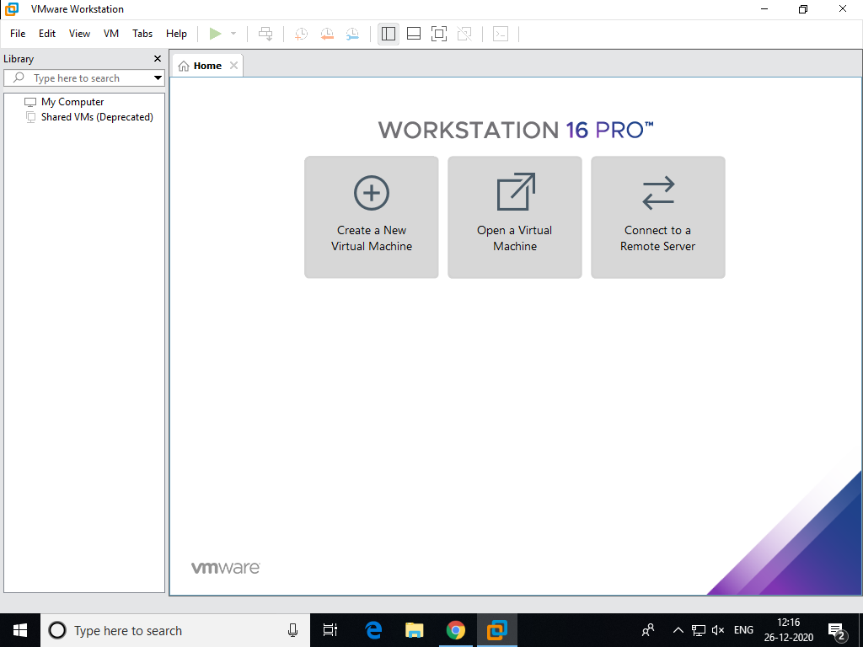

Result
Thus a procedure to install and configure VMware Workstation is identified and implemented successfully.

- Find procedure to create and run the virtual machine of different configurations. Check how many virtual machines can be utilized at particular time
Aim: To Find procedure to create and run the virtual machine of different configurations and to check how many virtual machines can be utilized at particular time
Procedure:
- Launch VMware workstation

- Click create a new virtual machine wizard
- Select custom installation radio button and click next
- Choose virtual machine hardware compatibility and click next
- Select I will install operating system later option from the guest operating system installation wizard and click next.
- Select the guest operating system and version and click next
- Give name to virtual machine and click next
- Configure processor, memory, network type(bridged), recommended I/O controller, recommended virtual disk type, select a disk, specify disk capacity(Store virtual disk as single file), specify disk file location with respect to the requirement of the guest operating system.
- Click finish button to complete the virtual machine configuration.
- Now a virtual machine is created.
- Repeat the above steps to create another 3 virtual machines.
- Before launching all the virtual machines note down and record the CPU, Memory, Disk and network utilization from the performance tab of the task manager of the physical machine.

- Launch all the virtual machines and note down and record the CPU, memory, disk and network utilization from the performance tab of the task manager of the physical machine
- Analyze the resources consumed by the 4 virtual machines and note down the changes in the resource utilization
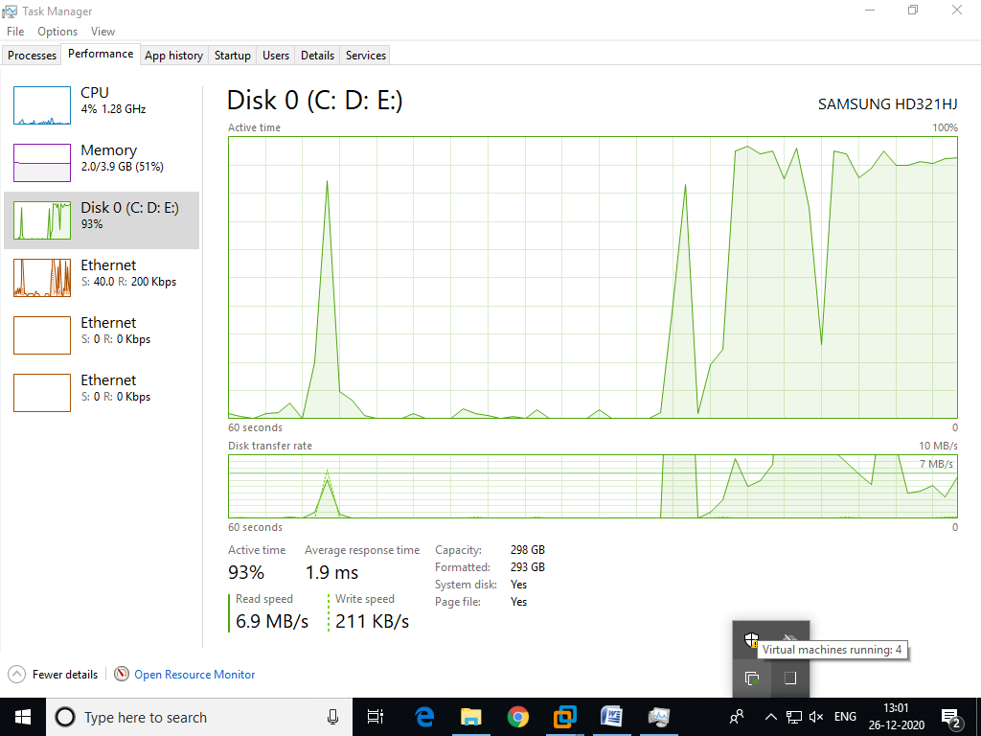

Result :
Thus a procedure to find procedure to create and run the virtual machine of different configurations and to check how many virtual machines can be utilized at particular time is identified and implemented successfully

- Find procedure to create virtual machines of different configuration and install desired operating system.

Aim:
To find procedure to create virtual machines of different configuration and install desired operating system.

Procedure:
- Launch VMware workstation

- Click create a new virtual machine wizard
- Select custom installation radio button and click next
- Choose virtual machine hardware compatibility and click next
- Select I will install operating system later option from the guest operating system installation wizard and click next.
- Select the guest operating system and version and click next
- Give name to virtual machine and click next
- Configure processor, memory, network type(bridged), recommended I/O controller, recommended virtual disk type, select a disk, specify disk capacity(Store virtual disk as single file), specify disk file location with respect to the requirement of the guest operating system.
- Click finish button to complete the virtual machine configuration.
- Now a virtual machine is created.
- Open virtual machine settings and click CD/DVD then select guest OS installation iso file and click ok.

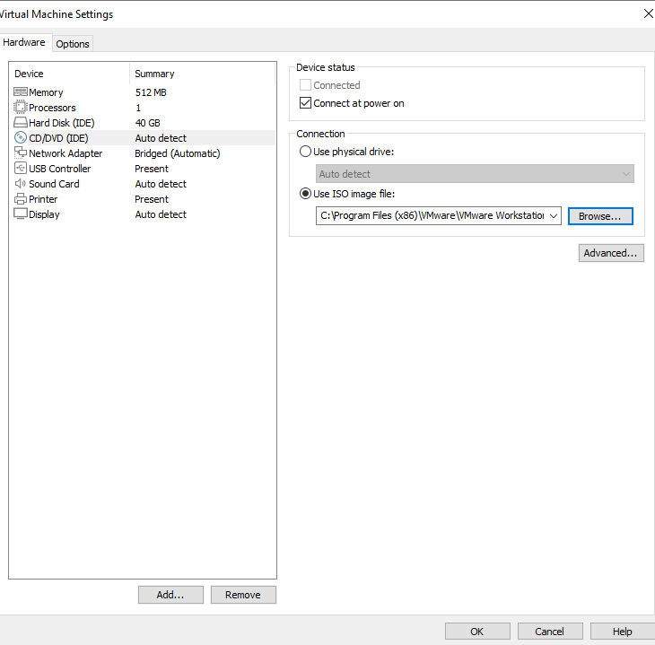
- Power on the virtual machine.
- Now virtual machine boots from OS installation media.
- Install the chosen guest operating system
- Repeat the above steps to create another 3 virtual machines.

Result:
Thus a procedure to create virtual machines of different configuration and install desired operating system is identified and implemented successfully.

- Install a C compiler in the virtual machine and execute a sample program.
Aim:
To install a C compiler in the virtual machine and execute a sample program.
Procedure:
- Launch a virtual machine using VMware workstation
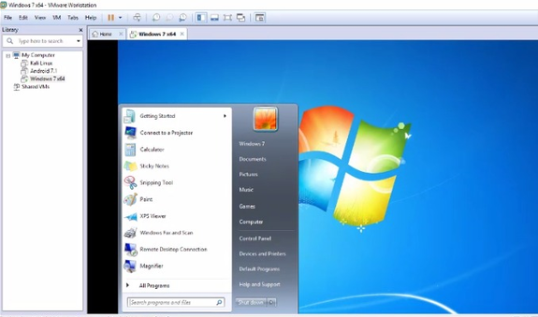

- Using a C language Installer, install a C compiler in the virtual machine
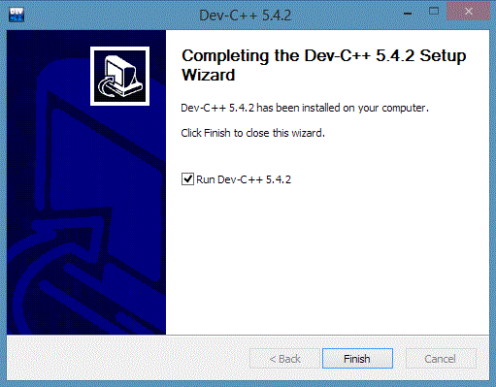

- Then write a simple C program and execute
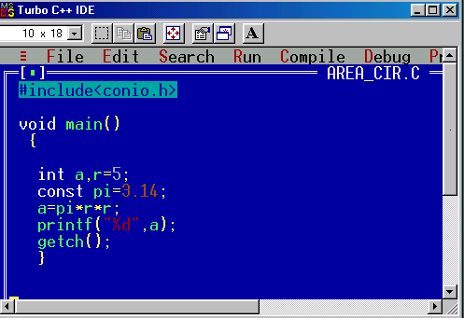

Result:
Thus a C compiler is installed in a virtual machine and a simple C program is executed

5. Find procedure to attach virtual block to the virtual machine and check whether it holds the data even after the release of the virtual machine.
Aim:
To find a procedure to attach virtual block to the virtual machine and to check whether it holds the data even after the release of the virtual machine.

Procedure:
- Launch VMware workstation
- Click create a new virtual machine wizard
- Select custom installation radio button and click next
- Choose virtual machine hardware compatibility and click next
- Select I will install operating system later option from the guest operating system installation wizard and click next.
- Select the guest operating system and version and click next
- Give name to virtual machine and click next
- Configure processor, memory, network type(bridged), recommended I/O controller, recommended virtual disk type.
- Select an existing virtual machine disk, specify disk capacity (Store virtual disk as single file), and specify disk file location with respect to the requirement of the guest operating system.
- Click finish button to complete the virtual machine configuration.
- Now a virtual machine is created.
- Store some data in the attached virtual block.
- Shut down and power off the virtual machine.
- Release that virtual block.
- Then attach that virtual block.
- Power on the virtual machine
- Check whether the virtual block holds the data after reattaching to the virtual machine
Result:
Thus a procedure to attach virtual block to the virtual machine and to check whether it holds the data even after the release of the virtual machine is identified and implemented successfully.

- Find procedure to install storage controller and interact with it.
Aim:
To find a procedure to install storage controller and to interact with it.
Procedure:
- Launch VMware workstation

- Click create a new virtual machine wizard
- Select custom installation radio button and click next
- Choose virtual machine hardware compatibility and click next
- Select I will install operating system later option from the guest operating system installation wizard and click next.
- Select the guest operating system and version and click next
- Give name to virtual machine and click next
- Configure processor, memory, network type(bridged), recommended I/O controller, recommended virtual disk type, select a disk, specify disk capacity(Store virtual disk as single file), specify disk file location with respect to the requirement of the guest operating system.
- Click finish button to complete the virtual machine configuration.
- Now a virtual machine is created.

- Open virtual machine settings and click add hardware wizard and choose hard disk, recommended virtual disk type, select a disk, specify disk capacity(Store virtual disk as single file), specify disk file location.
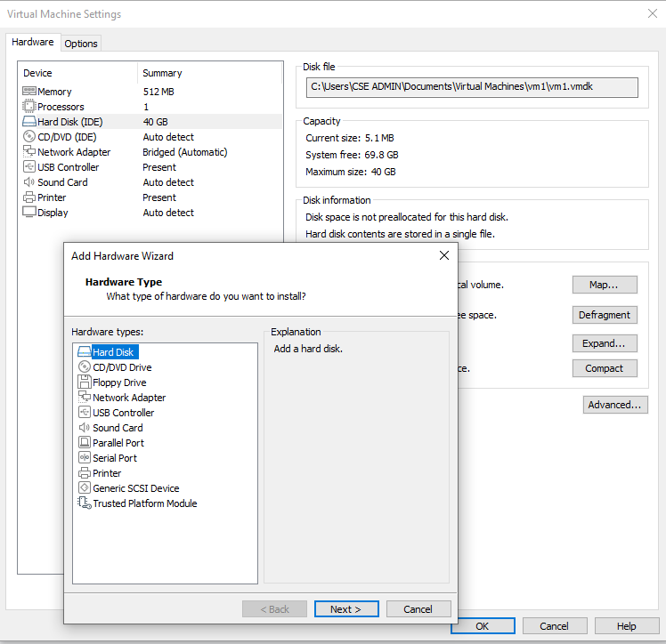
- Store data in the newly created storage

- Then open disk management option from the computer management interface and create file system and partition for new storage
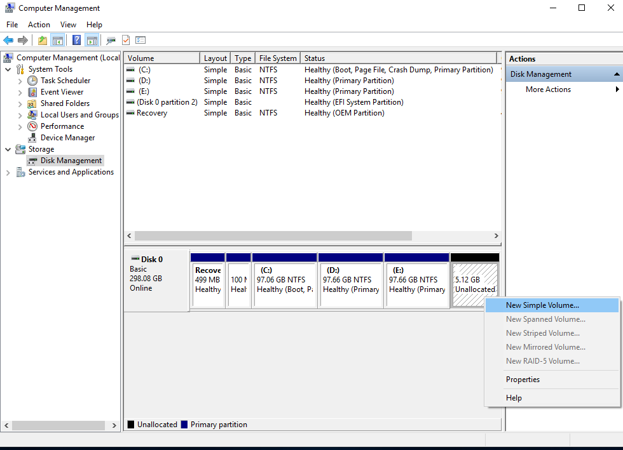

Result:
Thus a procedure to install storage controller is identified and also interacted with it.

- Find procedure to recover a virtual machine from snapshot
Aim:
To find a procedure to recover a virtual machine from snapshot
Procedure:
- Launch a virtual machine using VMware workstation

- Right click the virtual machine and choose snapshot » Take snapshot
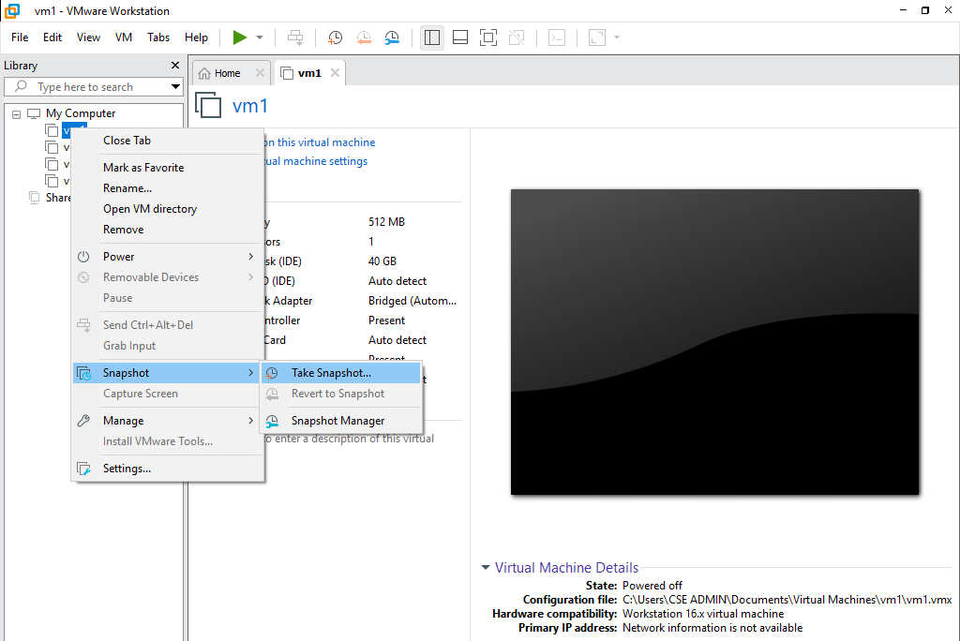

- Now a snapshot is created with the given name.
- To recover the virtual machine from that snapshot click the virtual machine and choose
Snapshot » Revert to snapshot : Choose the relevant snapshot.
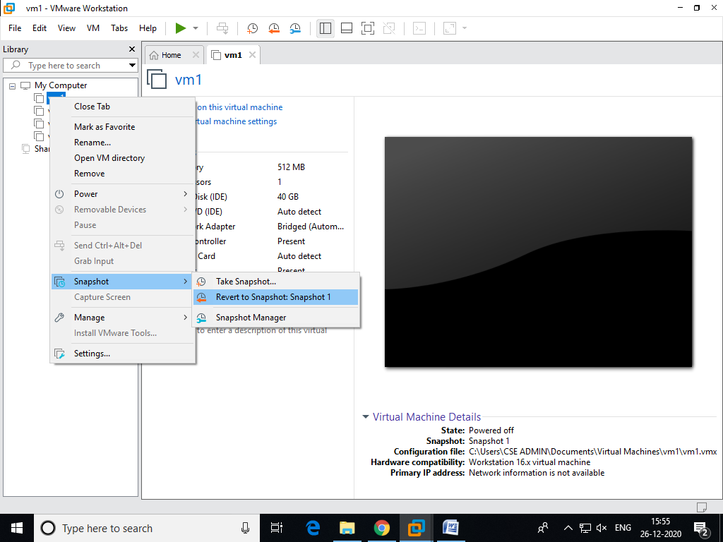
- Now this virtual machine is recovered from snapshot

Result:
Thus a procedure to recover a virtual machine from snapshot is identified and implemented successfully.

- Find procedure to convert a virtual machine into template
Aim:
To find a procedure to convert a virtual machine into template
Procedure:
- Launch VMware workstation

- Click create a new virtual machine wizard
- Select custom installation radio button and click next
- Choose virtual machine hardware compatibility and click next
- Select I will install operating system later option from the guest operating system installation wizard and click next.
- Select the guest operating system and version and click next
- Give name to virtual machine and click next
- Configure processor, memory, network type(bridged), recommended I/O controller, recommended virtual disk type, select a disk, specify disk capacity(Store virtual disk as single file), specify disk file location with respect to the requirement of the guest operating system.
- Click finish button to complete the virtual machine configuration.
- Now a virtual machine is created.

- Go to file menu and click export to OVF (Template)
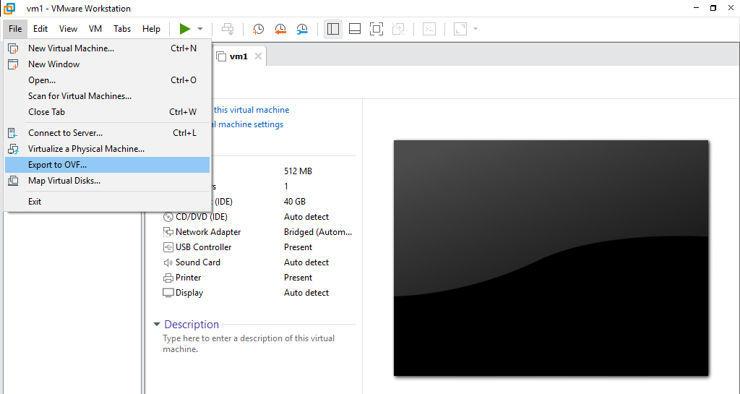

- Select the location to store the OVF file and click save
- Now a template of this virtual machine is created and stored in virtual machines folder
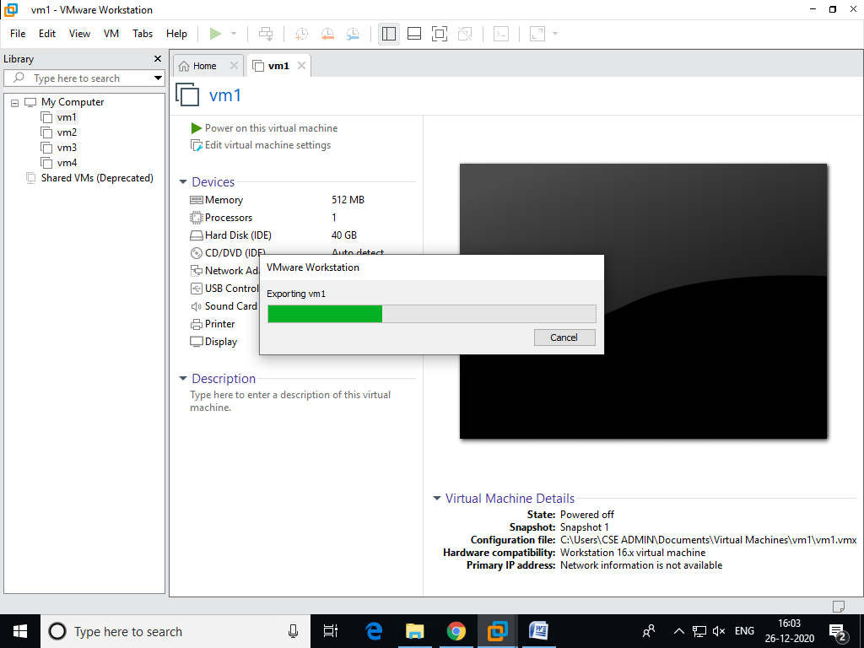
Result:
Thus find a procedure to convert a virtual machine into template is identified and executed successfully

- Find procedure to create virtual machine from templates
Aim:
To find a procedure to create a virtual machine from templates
Procedure:
- Launch VMware workstation
- Click open menu from the file tab and specify the location of the OVF(template)
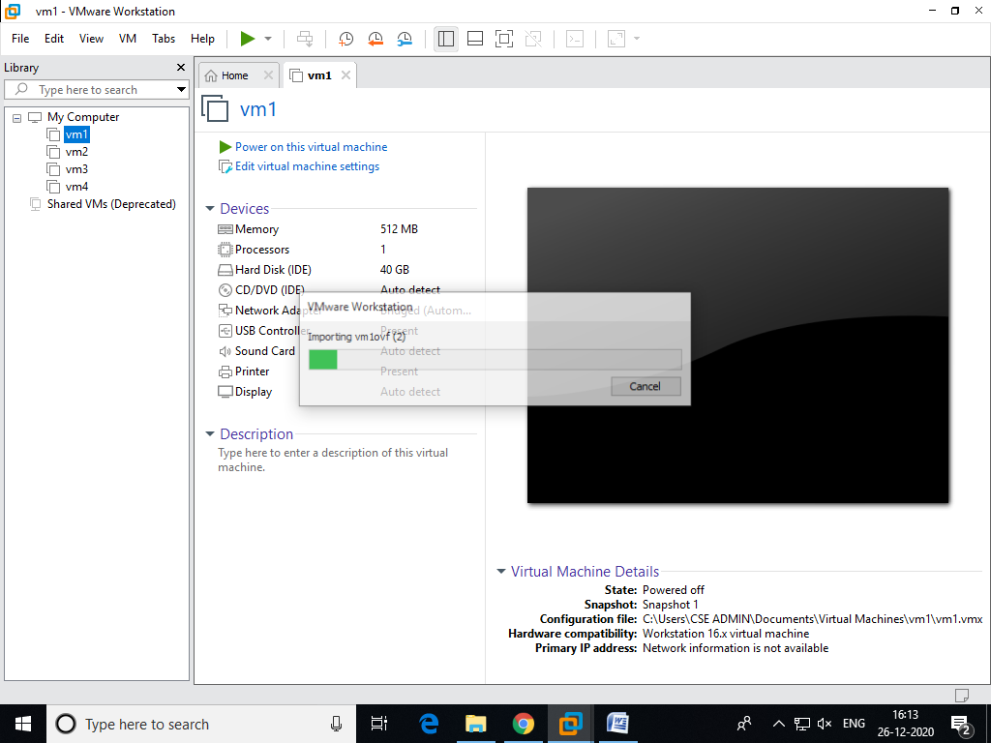

- Now a new virtual machine is created from the template
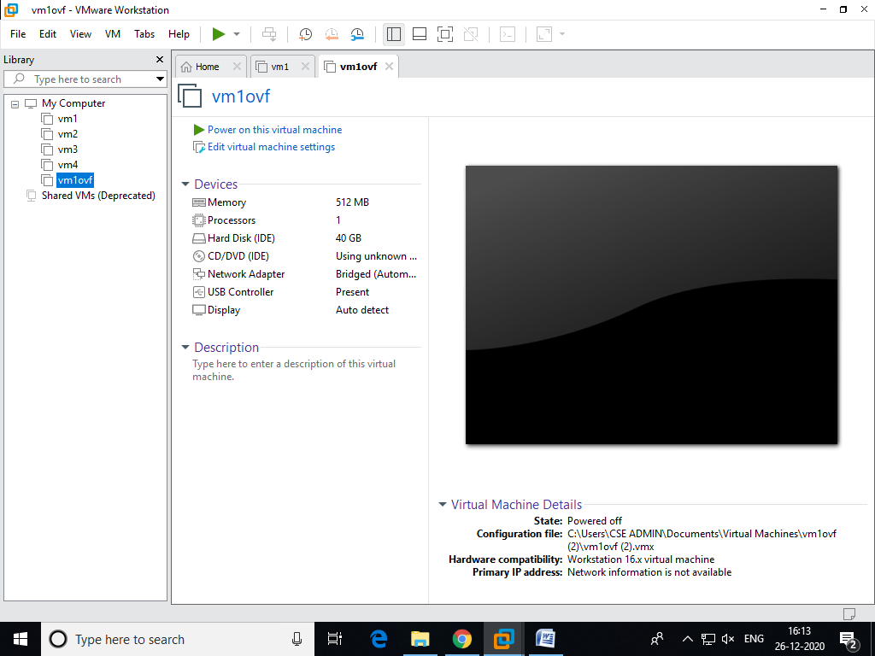

Result:
Thus a procedure to create a virtual machine from templates is identified and executed successfully

- Find procedure to perform networking between virtual machines
Aim:
To find a procedure to perform networking between virtual machines
Procedure:
- Launch VMware workstation

- In each virtual machines settings enable the shared folders options
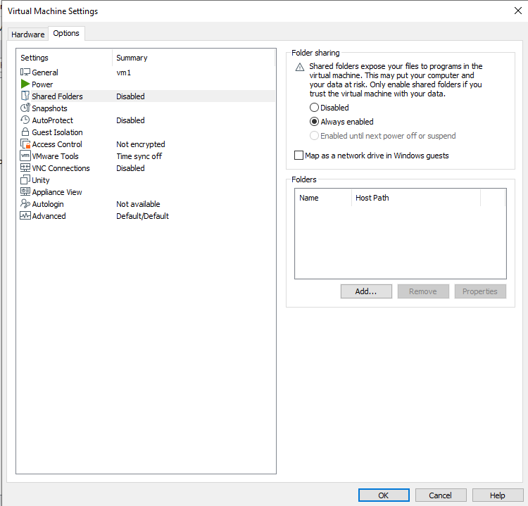

- Power on 2 virtual machines
- Assign ip address to each virtual machines which are in bridged network mode
- Make a folder as shared folder in each virtual machines
- Check the network connection between the two virtual machines using ping command
- Copy a file in one virtual machine (source), then go to browser/run command and type the ip address of another virtual machine (target).
- After the shared folder of target virtual machine is opened, paste the copied file and close all the windows.
- Open the shared folder of the target virtual machine and check whether the file copied from source virtual machine is present

Result:
Thus a procedure to perform networking between virtual machines is identified executed successfully.

